**Multiply-Questions**

Key Stage 3: 2003 Paper 1 Level 3-5

1.

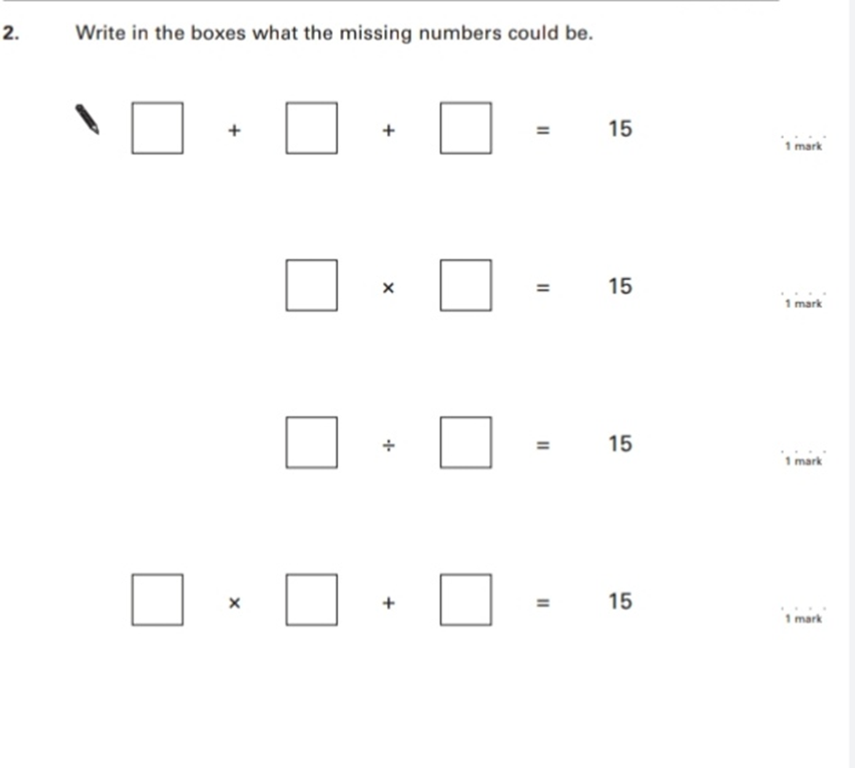

2.

Key Stage 3:2003 Paper 2 Level 3-5

3.

Key Stage 3: 2003 Paper 1 Level 4-6

4.

Key Stage 3: 2004 Paper 1 Level 3-5

5.

6.

7.

8.

9.

Key Stage 3: 2004 Paper 2 Level 3-5

10.

Key Stage 3: 2004 Paper 1 Level 4-6

11.

12.

13.

Key Stage 3: 2004 Paper 2 Level 4-6

14.

15.

Key Stage 3: 2005 Paper 1 Level 3-5

16.

17.

18.

Key Stage 3: 2005 Paper 2 Level 3-5

19.

20.

21.

Key Stage 3: 2005 Paper 1 Level 4-6

22.

23.

24.

Key Stage 3: 2005 Paper 2 Level 4-6

25.

26.

Key Stage 3: 2006 Paper 1 Level 3-5

27.

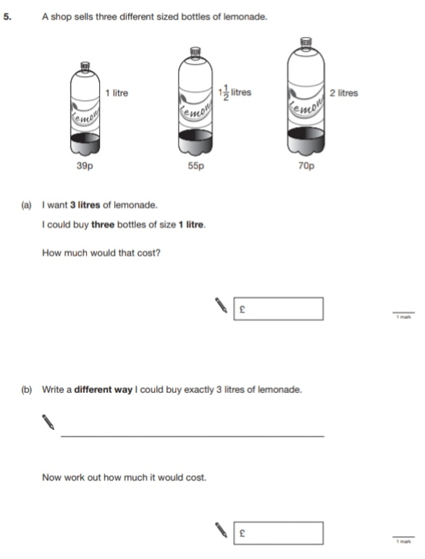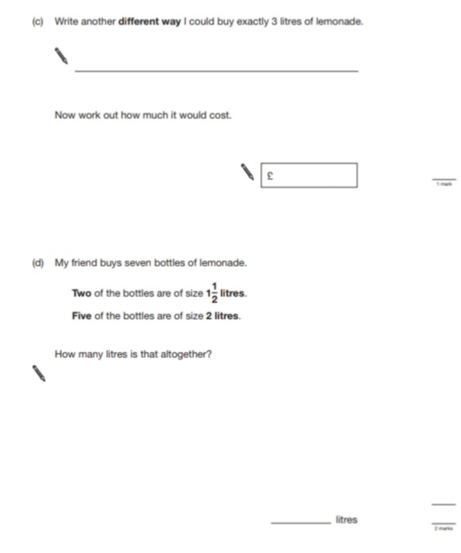

28.

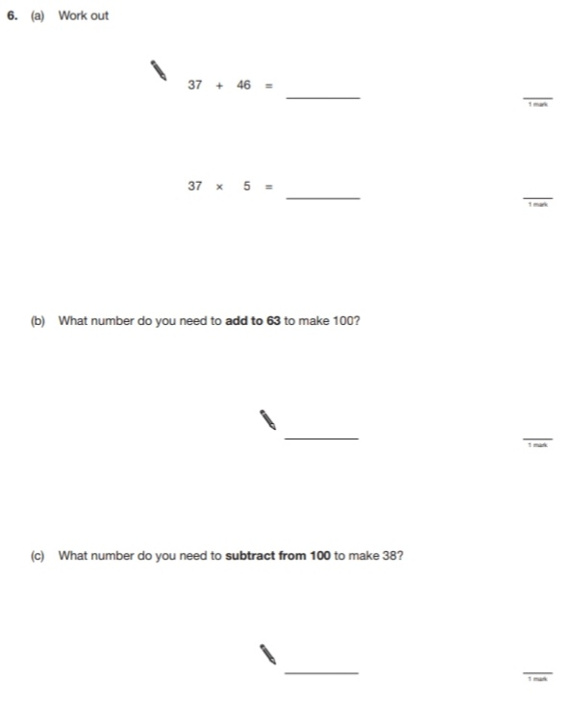

29.

30.

Key Stage 3: 2006 Paper 2 Level 3-5

31.

32.

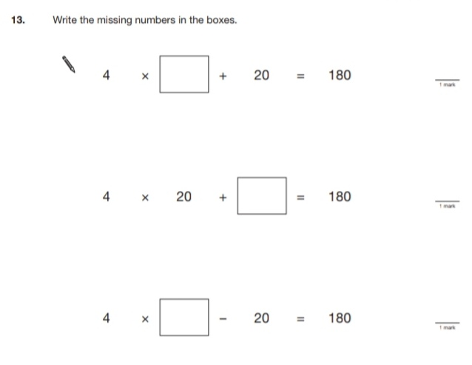

Key Stage 3: 2006 Paper 1 Level 4-6

33.

34.

Key Stage 3: 2006 Paper 2 Level 4-6

35.

36.

Key Stage 3: 2007 Paper 1 Level 3-5

37.

38.

39.

Key Stage 3: 2007 Paper 2 Level 3-5

40.

41.

42.

43.

Key Stage 3: 2007 Paper 1 Level 4-6

44.

45.

Key Stage 3: 2007 Paper 2 Level 4-6

46.

47.

48.

Key Stage 3: 2008 Paper 1 Level 3-5

49.

50.

51.

52.

53.

Key Stage 3: 2008 Paper 2 Level 3-5

54.

55.

Key Stage 3: 2008 Paper 1 Level 4-6

56.

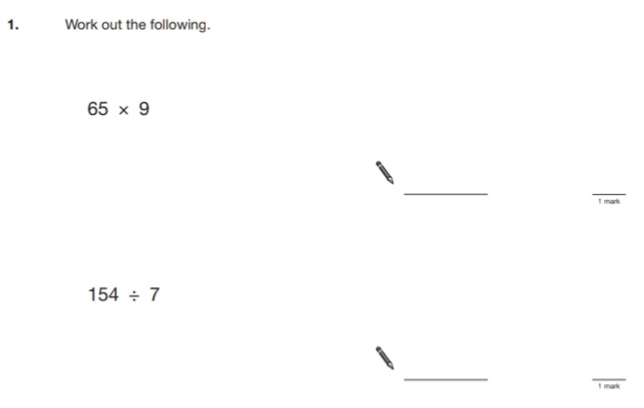

57.

58.

59.

Key Stage 3: 2008 Paper 2 Level 4-6

60.

Key Stage 3: 2009 Paper 1 Level 3-5

61.

62.

63.

64.

Key Stage 3: 2009 Paper 2 Level 3-5

65.

Key Stage 3: 2009 Paper 1 Level 4-6

66.

67.

68.

Key Stage 3: 2009 Paper 2 Level 4-6

69.

Key Stage 3: 2010 Paper 1 Level 3-5

70.

71.

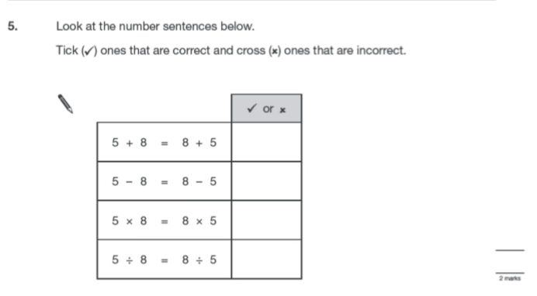

72.

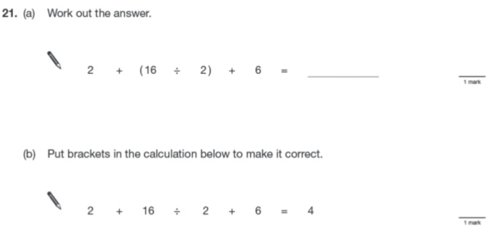

Key Stage 3: 2010 Paper 2 Level 3-5

73.

74.

Key Stage 3: 2010 Paper 1 Level 4-6

75.

Key Stage 3: 2010 Paper 2 Level 4-6

76.

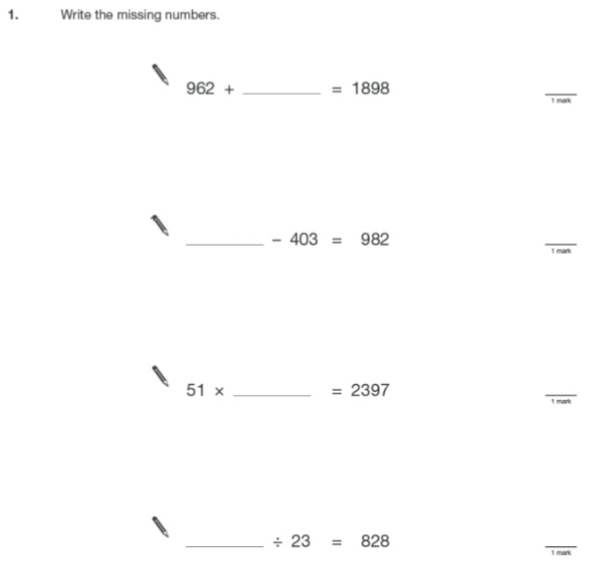

77.

Key Stage 3: 2011 Paper 1 Level 4-6

78.

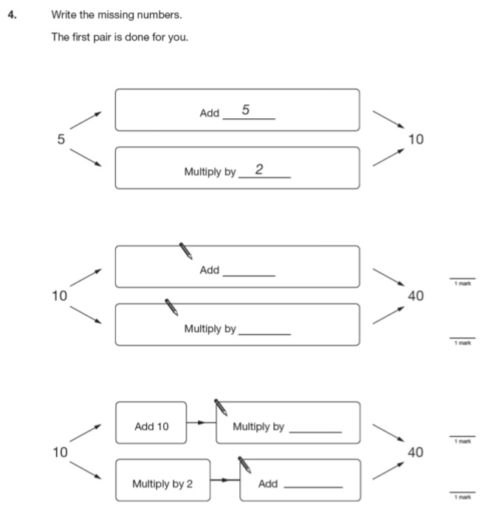

79.

80.

